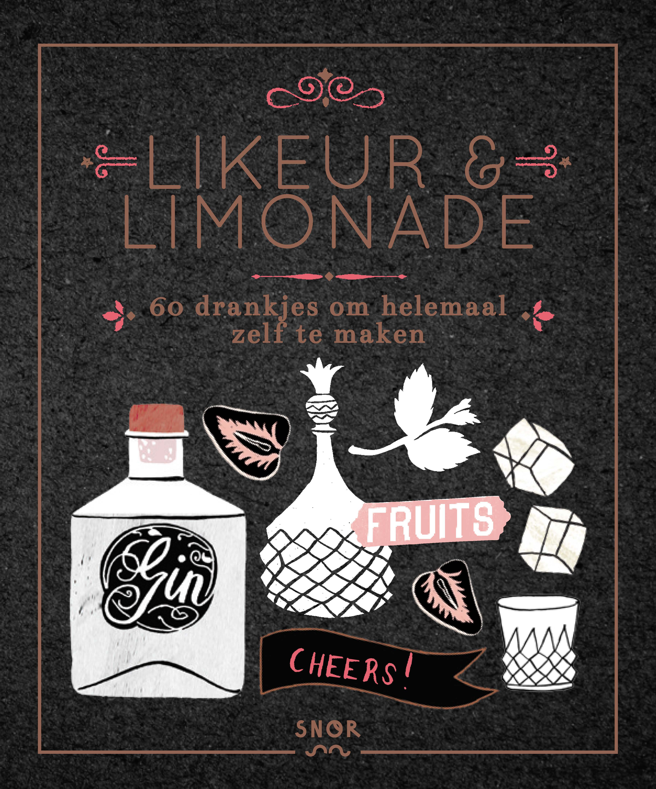
Liquor and Lemonades

Cocktails, syrups and liqueurs
With and without alcohol!

Cocktails are hot. And soft drinks too! This book combines these two trends together in a greedy manner. This fine hardcover illustrated by Deborah van der Schaaf, contains 60 recipes for liquors, syrups, cocktails and soft drinks. With and without alcohol. It’s so nice to brew a liquor and make a syrup of strawberries, limes or lemons. Before you know it, you can offer your friends a delicious homemade limoncello. Or a super festive (alcohol-free) cocktail of course!
You can make these recipes with the harvest of your garden, or with fruits and from the farmers market or store. With clear roadmaps and interesting information on how to use syrups and liquors.

Author: Rian Nix
Illustrations: Deborah van der Schaaf
Design: Studio 100%
Size: 150 x 180 mm
Pages: 144
Publishing date: September 2016
Price: 16,99

Key selling points:
- Fits in the international cocktail trend
- Perfect for those who love to makes things by their own

Printer specs

Extent : Cover
inside 144 pages ends
Size : 150 x 180 mm
Paper : cover 135 gsm glossy art
inside: 120 gsm wf offset
ends 140 gsm wf offset
Printing: cover 4/0 (fc) + 1/0 matt lamination
inside 4/4 (fc)
ends 4/4 (fc)
Binding: thread sewn, hardcover on 2,5 mm board, straight spine, H&T bands
Word count: about 7.000 words

