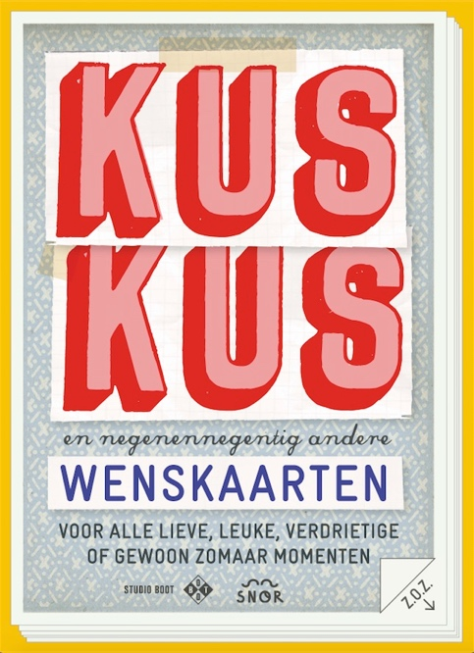
Kiss Kiss and 99 other cards

100 cards for every oppurtunity

A card to wish strength to someone, to congratulate, or just to letting know that you think of him or her. Because you do not know in advance when you need which card, it is handy to have a pile at home. Or this beautiful hardcover cardbox which contains 100 colorful postcards. There is always a card that you need at that moment in this cardbox from Studio Boot.

Studio Boot is an award winning design firm in Den Bosch. They are known for their exemplary procedural legislation. They made countless books with Snor, including ‘Self Harvested’, ‘Make your Own’ and ‘Nine Months Pregnancy Scrapbook’.

Author: Studio Boot
Design: Studio 100%
Size: 105 x 148 mm
Amount of cards: 100
Publishing date: September 2016
Price: 19,99

Key selling points:
- International price winning illustrators with a lot of international fans
- Beautiful box with 100 post cards
Printer specs
Title : Sets playing cards
Extent : sets of 100 cards
Size : 105 x 148 mm
Paper : 250 grs C1S artboard
Printing : 4/1 + 1/0 gloss UV lack
Pre-press : Certified PDF files by FTP server
Binding : collect sets
Packing : in playing box
Title : Gamebox
Extent : box and lid
Paper : outside 125 gsm glossy art paper
Printing : Box and lid 4/0 + 1/0 lamination
Binding : cover on 1.5 mm board glued and set up (grey inside)

printing with 2 pms colours

