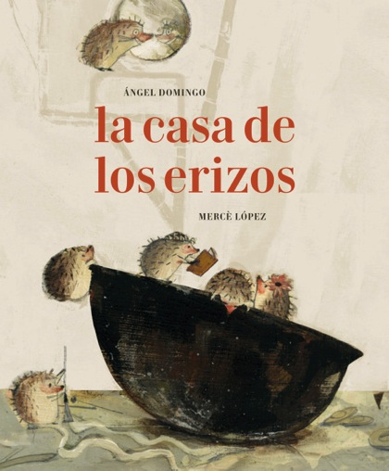
La casa de los erizos
The hedgehog Home
Ángel Domingo (text)
Mercè López (illustrations)
19 x 23 cm / 56 pages
Hard back, it includes flaps in the inside
PVP: 16,35 euros + VAT
ISBN: 978-84-945038-2-5

The hedgehog family is looking for a warm home where they can spend the winter.
They will find it in least likeable place.

When the winter comes and it is so cold that their noses becomes numb and their sneezes get frozen before getting out of their mouth, the hedgehog family decides that the time has come to look for a warmer home. So that mum, dad and their 9 children –each one showing its own charming personality in the beautiful illustrations– star a journey through the woods.
But looking for a home is not an easy task, and the hedgehog family will have to turn down the offers made by the mole, the stork, the squirrel, and the weasel. The will find the perfect place in a weird metallic construction, a wheeled home, that used to belong to humans.
What they do not know is that they have found a tank.
A story where the reader can feel the warmth of family love, in contrast with the destruction brought up by war. A story whose words, full of a sometimes sweet, sometimes bitter irony, accompany the reader to discover life mysteries. A life that can be so beautiful and so hard at the same time.

