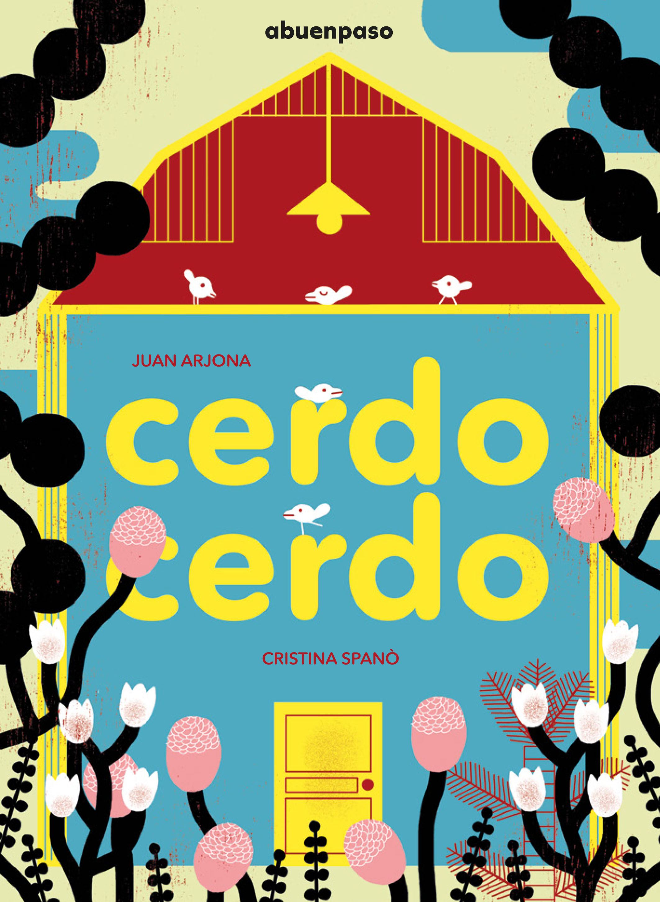
Cerdo cerdo / My Little pig
Juan Arjona (text)
Critina Spanò (illustrations)
17,5 x 24 cm / 36 pp / HB
PVP: 13,46 euros + IVA
ISBN: 978-84-946368-X-X

A true pig,
a real pig, loves to hang out
with his friends, jump into ponds,
climb up the hill… And he really doesn’t like
being called little pig.

This is a sweet book where the reader will be able to follow the daily routine of a little pig who loves playing with his friends, bathe into the mud, runs away in fear of the thunder and rain, stares in awe at a beautiful landscape.
The main character of this story feels so big that he doesn’t even notice how small he is compared to his friend the elephant, or the horse or the bull. He wanders through the world, discovering its beauty.
The narrator follows him with care and attention, creating a cumulative game which is enriched by the employ of onomatopoeias that express emotions and feelings of the main character.
Cristina Spanò’s illustrations are drawn with strong and bright colours, they play with shapes and the overall composition of each spread, thus capturing the funny, innocent and passionate spirit of this story.

Juan Arjona (Sevilla, 1975) simply loves creating a story and telling it through a book, a drama or a comedy, or through his own voice. This is why his career ranges from being a narrator, write, to being theatre director. He has participate in most festivals in Spain, and mainly develops his theatrical work inside the Barataria Company, which he founded in 1998. In A buen paso he has published the books belonging to the Antonino and Bear series, and then Amiga gallina, Soy pequeñito, Una vaca y Una historia verdadera (El cuento de los guisantes).

Cristina Spanò (Roma, 1985) she illustrates for the press (The New York Times, The Boston Globe, The National Public Radio), creates her own comic books and graphic novels (Habitaciones íntimas, Bang Ediciones, 2014), and she also illustrates children’s picture books (in Italy, for instance, she works for La Nuova Frontiera Junior). In 2016 she has been selected into the catalogue promoted by American Illustration. And in 2017 her illustrations have been selected in the Bologna Bookfair Exhibition.

