We love you
Friends book for adults

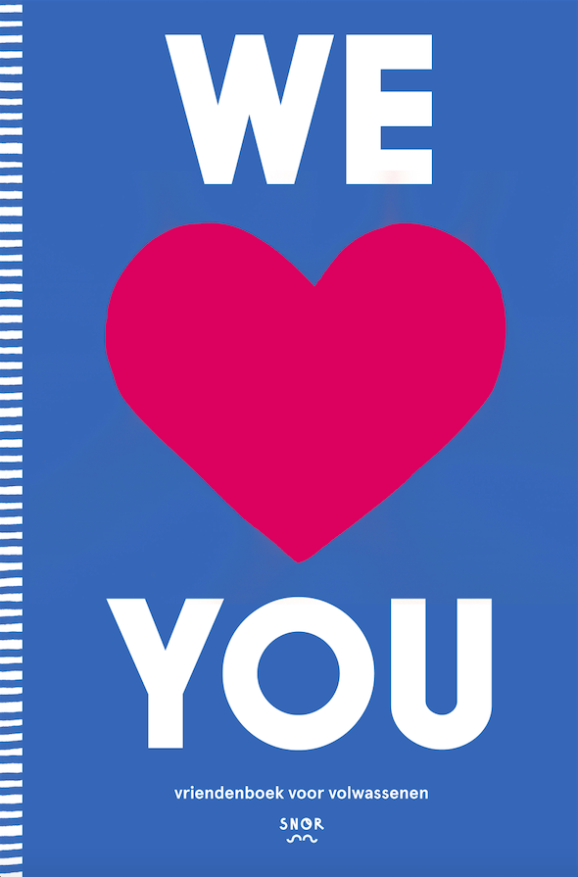
Positive feedback from your environment is a proven instrument of the Positive Psychology. With this, you will appreciate your own talents more so that you will be able to use these talents even more. Is there a better gift than that? Yes, there is. That feedback combined, to leaf through again and again. Here is the book where you can fil in the blanks: We love you, Friends Book for Adults.
This Friends Book contains questions like: "Do not worry about ..." "The best thing about our friendship is..." "Your strengths are ...." The questions are designed by Ivo Jansen, who was inspired by an exercise of the Positive Psychology, the Reflected Best Self Portrait. The focus is on the positive experience of people. The epilogue of the book is written by Jan Walburg, Professor of Positive Psychology.
After reading the complete filled book, you know better what you mean for your friends. And you get an idea about what qualities you could use even more often. Such a heartwarming gift you’ve never got! Illustrated by Sue Doeksen, designed by Ricardo Leite.

Author: Ivo Jansen
Illustrations: Sue Doeksen
Design: Ricardo Leite
Size: 167 x 250 mm
Pages: 112
Publishing date: September 2016
Price: 16,99

Key selling points:
- The perfect gift for bachelor parties, birthdays, retirements etc.
- Personal growth with the positive feedback gathered in this book
- A beautifully warm book filled with memories, which makes every special occasion even more special

Printer specs

Extent : Cover 4 pages + flaps
inside 112 pages
Size : 166 x 250 mm
Paper : cover 300 gsm 1 side art board
inside: 115 gsm Munken print white 1.5
Printing: cover 4/4 (fc) + 1/0 matt lamination
inside 4/4 (fc)
Binding: Sewn Otabind
Word count: about 1.507 words

