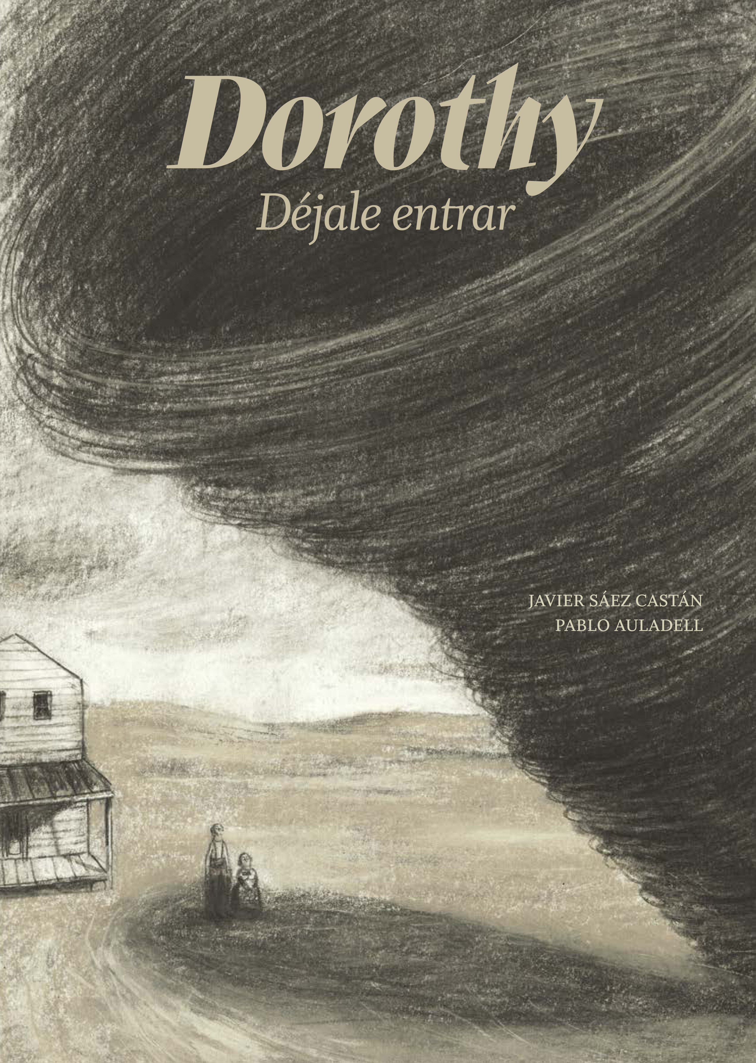
Dorothy
Déjale entrar / Let her in
Javier Sáez Castán (text)
Pablo Auladell (illustrations)
21 x 29,7 cm / 40 pages / HB
ISBN: 978-84-946368-4-4

Jonah and Martha live in a farm in Kansas. Martha spends the whole day reading Selections of the Reader’s Digest and any book reflecting the thought of any culture (from Darwin to Indus texts) and regarding human evolution, and the meaning of life. Jonah listens to her and –overwhelmed by the clearness he perceives in her words– he always agrees with her. The day a little tornado enters their backyard, they decide to adopt her. They will call her Dorothy and she will change their lives forever.
A tale that is born in our common imaginary and literary references, and that immediately becomes a story at the same time surrealist, but also pervaded by a tremendous realistic feeling. This feeling –combined with the power of Pablo Auladell’s images– will take the reader into his world, just like Dorothy does with Jonah and Martha.
This book has won the International Picture Book Prize Biblioteca Insular de Gran Canaria. In 2016 Pablo Auladell has also won the National Comic-book Prize, and Javier Sáez Castán the National Illustration Prize.

