Winter BBQ-book

WINTER BBQ PARTY WITH MADAME CHARLOTTE
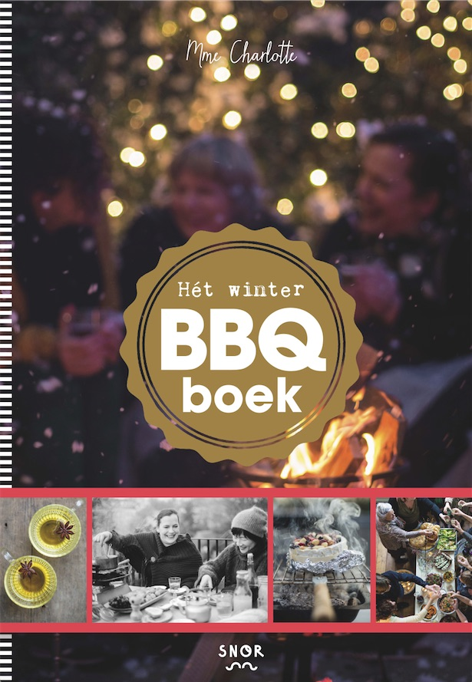
Food cooked on a charcoal fire is so much better than just from a pan. Not only in the summer, also in autumn and winter more people firing their barbecue. Madame Charlotte, author of ‘On Fire’ and thereby winner of the Gourmand Cookbook Award 2014 for the best BBQ book in the world, swears by barbecuing when it gets colder. It’s nice to be around a cooking fire all together, eating and having a drink.
For this book Madame Charlotte wrote recipes as Bruschetta with mushrooms, Porchetta with ham and sage and Guinea fowl with orange salsa. And what about the winter coleslaw side dish of red cabbage, parsnip and carrot?
Completed with winter drinks, styling tips and wintry playlists. With all the tips and tricks to build yourselves a successful party. And firing up the BBQ!

Author: Charlotte Fielmich
Photographs: Saskia Lelieveld
Design: Studio 100%
Size: 170 x 240 mm
Pages: 144
Publishing date: September 2016
Price: 14,99

Key selling points:
- Perfect gift
- From author Madame Charlotte, who won the Cookbook Award 2014 for the best BBQ book in the world
Printer specs
Extent : Cover
inside 112 pp
ends
Size : 170 x 240 mm
Paper : cover 135 gsm halfmatt art paper
inside 135 gsm half matt art paper
ends 140 gsm wf ofset
Printing: cover 4/0 (fc) + matt lamination
inside 4/4 (fc)
ends 4/4 (fc)
Binding: sewn in sections, cover on 2,5 mm board, straight spine, H&T bands
Word count: about 11.000 words

