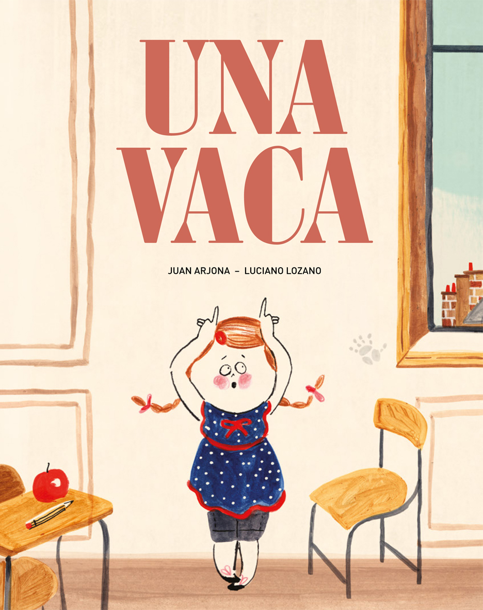
A Cow
Juan Arjona (text)
Luciano Lozano (illustrations)
21 x 26,5 cm / 32 pages / HB
ISBN: 978-84-944076-5-9

At 7:12 a.m., in the city you can hear
the car engines rumbling,
because everybody is going to work.
Between the sun beams and people’s rush,
in the distance, from the Northern avenue, suddenly somebody hears a cowbell ringing.

One day in the city strange things happen: some people swear they have seen a cow strolling by, two painters fall from the scaffolding they are working on, but luckily fall onto a white mattress that has some peculiar black stains; some thieves can’t escape because something is obstructing their way …

Indeed at dusk, between the night breeze and the morning buzzing, a cow leaves town and goes back to the meadow.

A delicate tale written by Juan Arjona and illustrated by Luciano Lozano that makes us think about the strength of the destiny and the power of coincidence that sometimes make our life a little bit more unpredictable, surprising and easy.

