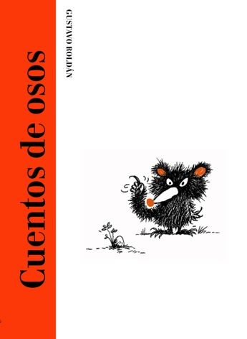
Cuentos de osos
Bears’ tales
Gustavo Roldán (text and illustrations)
17,5 x 24 cm / 48 pages
hard back with cloth spine
PVP: 13,46 euros + VAT
ISBN: 978-84-945038-1-8

Bear Dad is an awesome bear,
except when he starts reading his child
bedtime stories. In fact, he each time manages
to make him immediately fall asleep.
Somebody will have to find a way
to fix this situation!

How does a bear write? According to the little bear’s father you have to write using bear sensitivity, bear poetry, and bear gentleness. However his son doesn’t agree with him, and will take advantage of the stillness of the night to retouch his dad’s stories…
How will bear dad and his son react to the unexpected consequences of this action?
A story that celebrates the mutual understanding between a dad and a son, while at the same time the images that accompany the words overflow with Gustavo Roldán’s visual humour.

