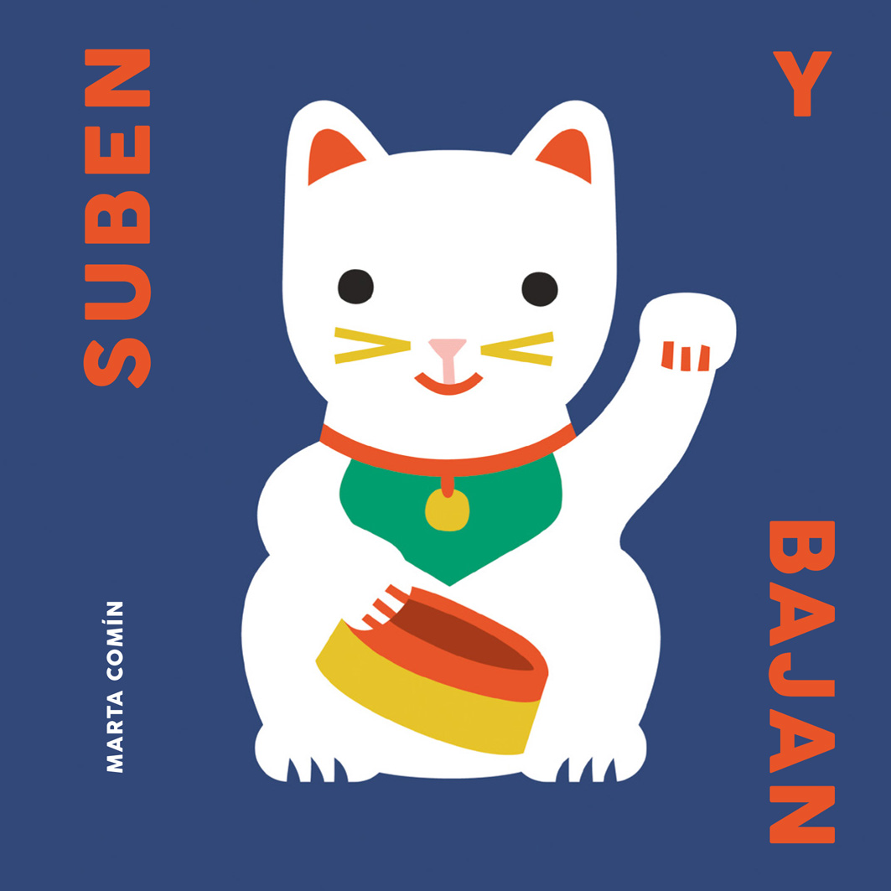
Suben y bajan
Marta Comín (text and illustrations)
18 x 18 cm / 36 pp / HB
PVP: 11,54 euros + VAT
ISBN: 978-84-946368-8-2

I get puzzled in front a few things:
for instance, the mountains peaks,
do they go up or down?
It all depends on your point of view.

Some things, like ripe fruits, always go down; on the other hand, there are others that always move upwards. But there are also thing that sometimes go up, and sometimes go down. A few times you can understand why, but not always. What kind of relationship develops between the concepts of going up and down? Can you go down and never go up and vice versa?
The author of this book creates a sequence of illustrations that analize the relationship between these two actions. Thus she feels she is exploring the Taoist principle of duality. In each thing or situation you can find two fundamental forces, they are opposite and complementary.
Marta Comín’s images propose her thoughts on this issue through a beautiful and metaphorical rendering.
The narrator stares at the world that surrounds him or her and tells us his or her thoughts. This narrator can be a child or can be you or me. This is a little book to discover a new concept, a book that will surprise you talking about simple everyday facts, those facts one rarely thinks about.
A fascinating books for both children and adults.

Marta Comín (Santander, 1982), she has studied art in the Universidad Politécnica, Valencia, where she actually lives. She employs words and illustration to make her own observations, to develop her own thoughts and to discover peculiar concepts. Through her illustration where she plays with the relationship between empty and full space, and with a synthetic drawing, she aims to create humorous images that allow the reader to see things from a new point of view. In 2016 she has published her first children’s picture book, Pelos, published by the Universidad Politécnica.

