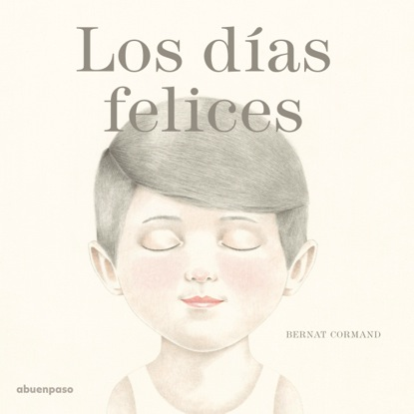
Los días felices / Happy days
Bernat Cormand (text and illustrations)
22 x 22 cm / 36 pp. / HB
PVP: 15,38 euros + IVA
ISBN: 978-84-947446-9-3

Two boys, one village spread
between the see and a hill,
a childhood tale,
a tale of happiness and abandonment, the discovery
of a secret place.

The main characters of this tale are two boys –the narrator and Jacob–, a place –a village placed between the see and a hill–, and time. The time that belongs to the games, when each one realizes he has found a partner to share dreams, challenges, hopes and fears. And time to remember and to feel an unbearable longing, because one day Jacob’s family leaves without saying goodbye.
What’s left for the person who is still there? The pain, the abandonment, as big as a mountain? A memory that allows you to hope? A surprise hidden in a secret place?
A tale told like an elegy, a tale that flows like our own memories, illustrated in a realistic style, that also offers symbolic elements that invite the reader to contemplate the beauty of art and literature, and finally to think about the things that really matter in life.

