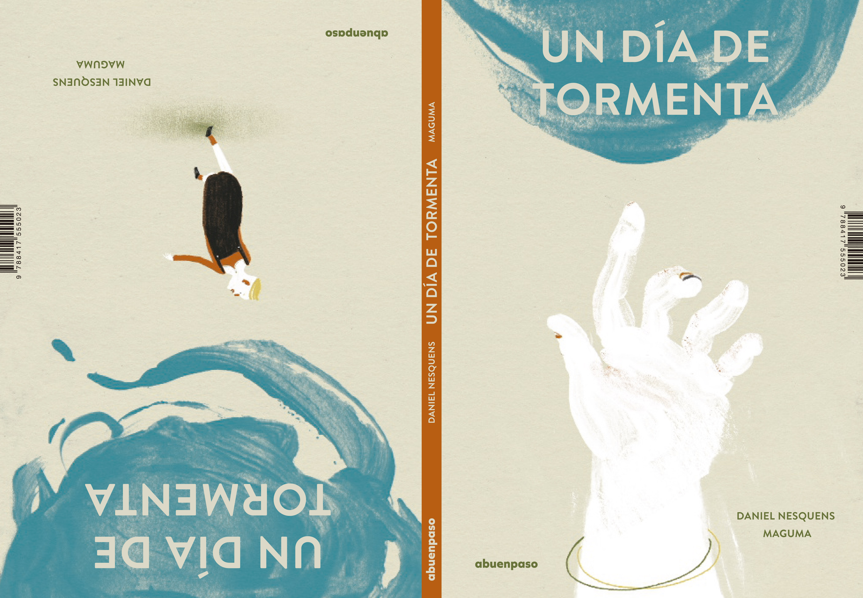Un día de tormenta / A Stormy Day
Daniel Nesquens (text) & Maguma (illustrations)
16,5 x 24 cm / 36 pages / HB - PVP: 13,46 euros + IVA - ISBN: 978-84-17555-02-3

Two surrealistic and amusing stories
whose characters accept whatever happens
no matter how weird or upsetting it seems.

This beautifully illustraded two-sided book offers two stories that meet in the middle: on one side two men are walking along the street, when it begins to rain. In a pond at their feet, they see surfers and ships travelling as if they were in the middle of the ocean.
On the other side of the book, a family lives a weird experience: from the ceiling of their appartment comes the strangest flood you could ever imagine. And soon enough, the upstairs neighbours also drop down with the water. And as the water continues to rise, it is our very heroic family that is falling downstairs, carried by the drops of water.
Two surrealistic stories, written in the pure Daniel Nesquens’ style, in an apparently plain language, but full of little details. Maguma’s illustrations play at imagining gigantic gods that observe the small lives of a bunch of human beings who can’t help being carried away by the water.

